Smart Sowing and Self- Planting Robot using ESP32

Materials& Links | Links | Description | Price And Proof
LM2596 DC DC Step Down Converter with LED Display Voltmeter | https://ph.shp.ee/hWLzzHm3  ph.shp.ee  ph.shp.ee | Reduce or adjust the voltage from battery according to the need of components | P 89  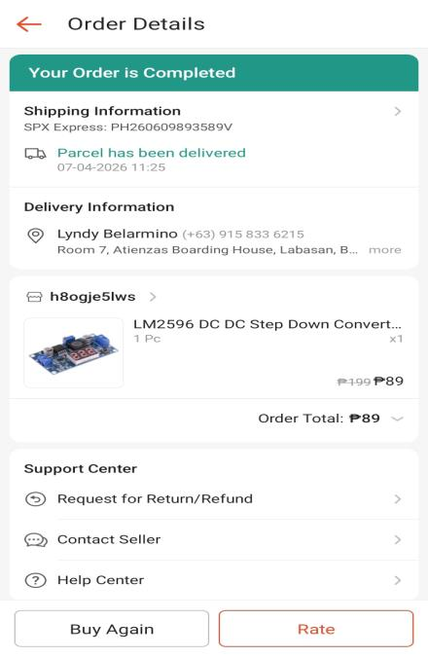
12V Lithium Battery Li-Ion (rejected) | https://ph.shp.ee/cZvYxgvG  ph.shp.ee  ph.shp.ee | Not used | P 109  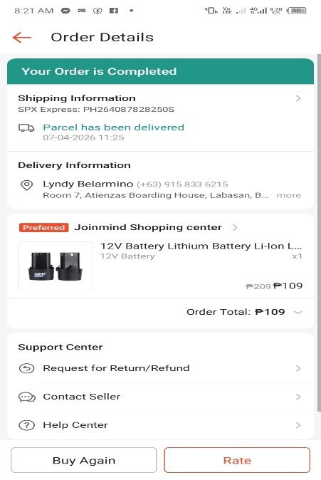
Soil Moisture Sensor | https://ph.shp.ee/fpq6CAfk | Not Used | P 60  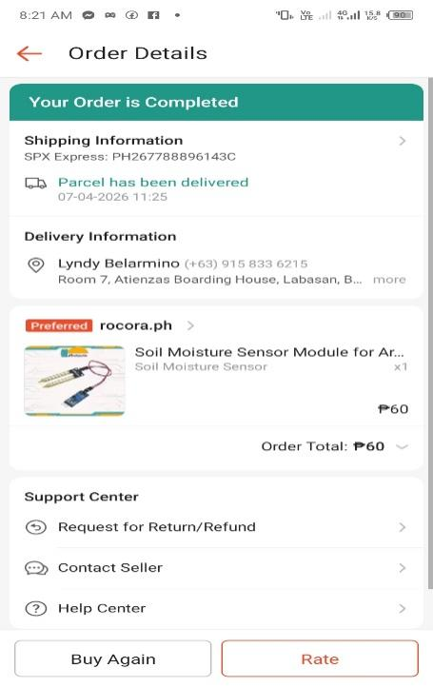
DC Motor 12V 12000RPM (rejected) | https://ph.shp.ee/i326boXS | Not Used | P 178  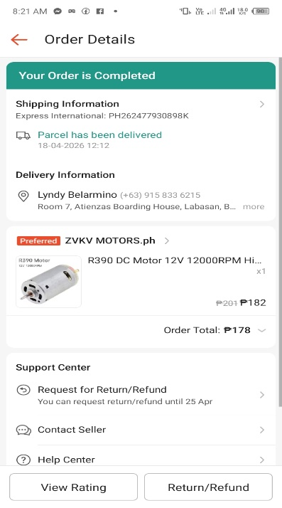
Double BTS7960 Motor Driver Module | https://ph.shp.ee/2XRNmJtP | Controls the speed and direction of motors | 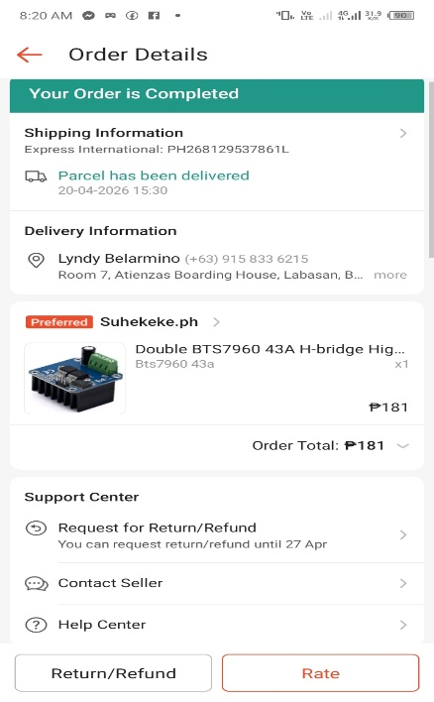  P 181
SG90 Micro Servo Motor | https://ph.shp.ee/bSiFuZBx | Used for precise movement like seed dropping | P 234  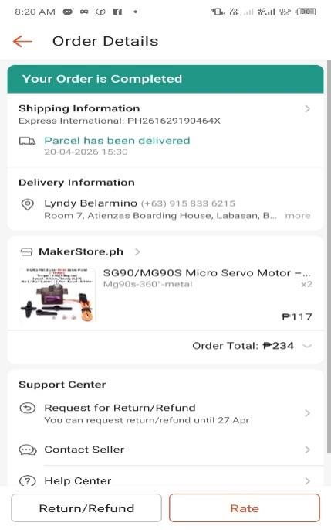
SG90 Micro Servo Motor- Servo Tester and Bracket | https://ph.shp.ee/X9JTB9Vv | Help test and support the servo motor | P 98  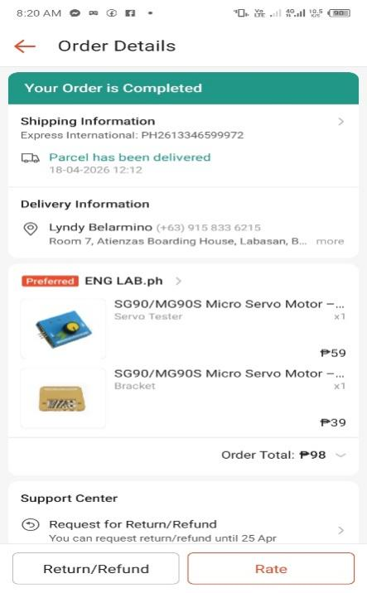
DC Motor 12V 100RPM | https://ph.shp.ee/GVNgNpth  ph.shp.ee  ph.shp.ee | Not Used | P 422  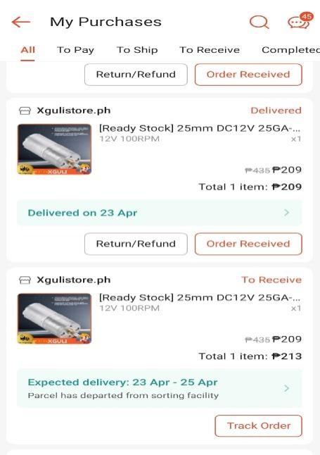
6 Hole single Mouth Seeder | https://ph.shp.ee/1bVhF1Kd  ph.shp.ee  ph.shp.ee | Device that drop the seeds evenly | P 3,678  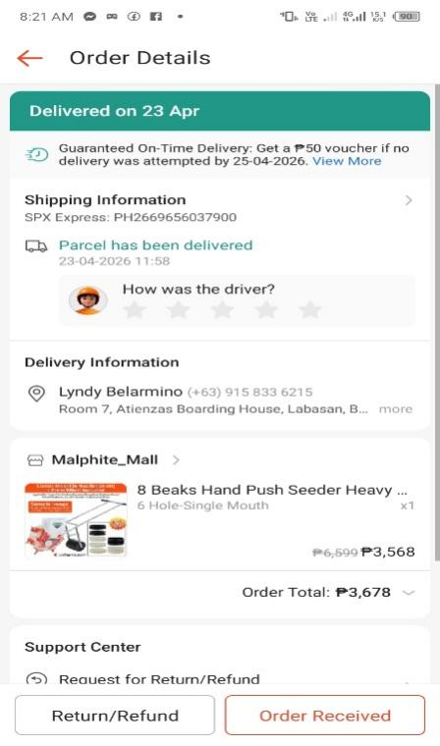
 | https://vt.tiktok.com/ZS9N6SWAGjPK9-BY37T/ | Help to move in different direction | P 296  
12v 120w DC high powered motor |  | Movement for forward and backward | 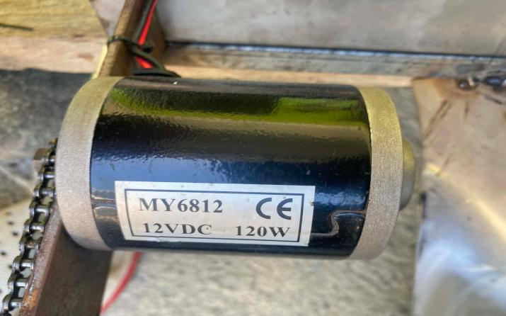
Switch |  | On and off button | 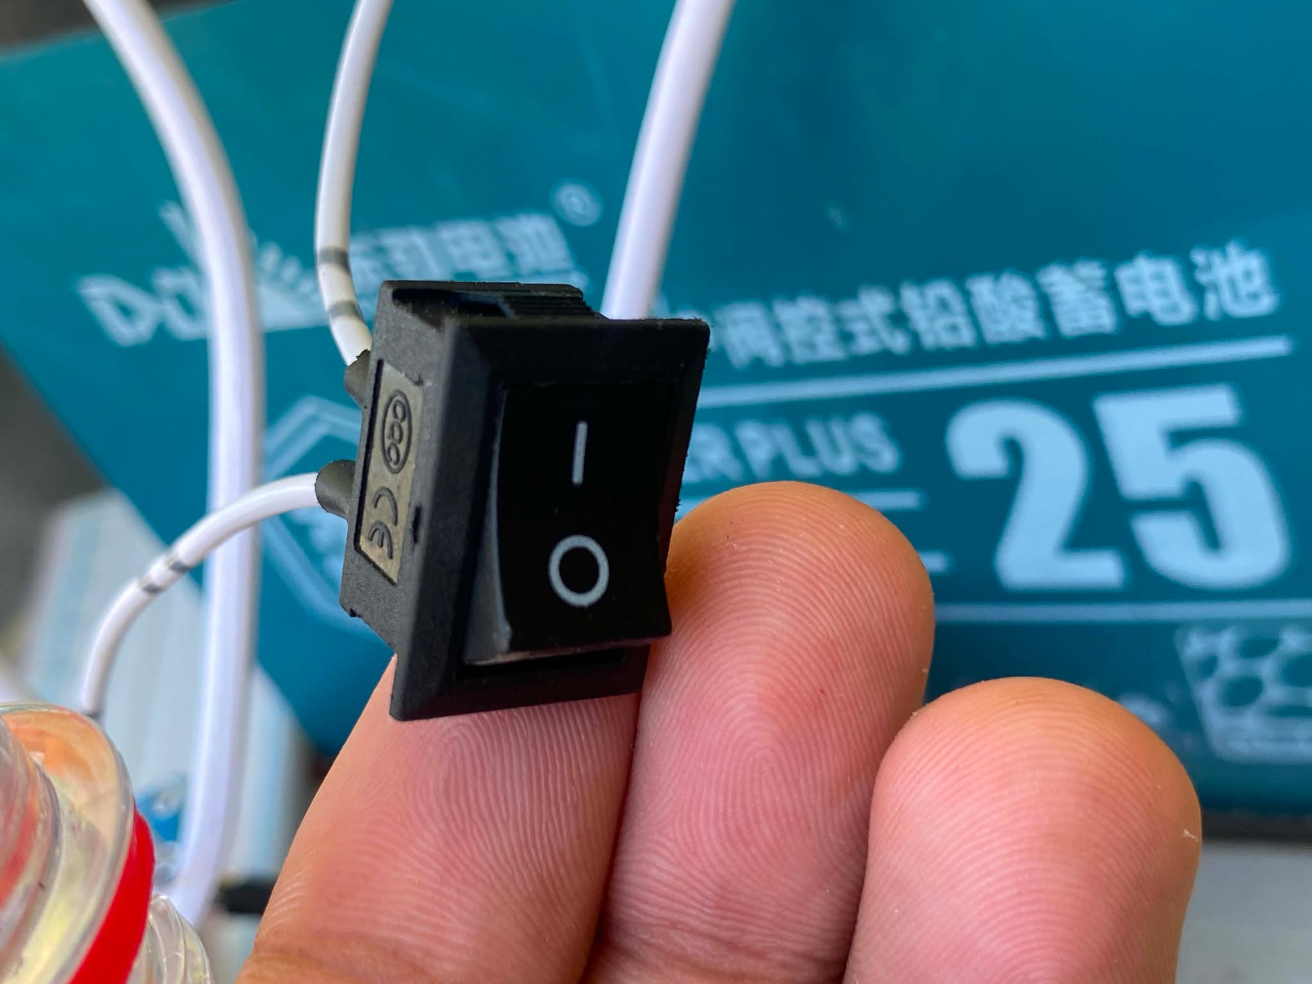
DongJin Power Ebike Battery 12V 25AH compatible with 12V 20AH Deep Cycle GEL Battery |  | Battery | 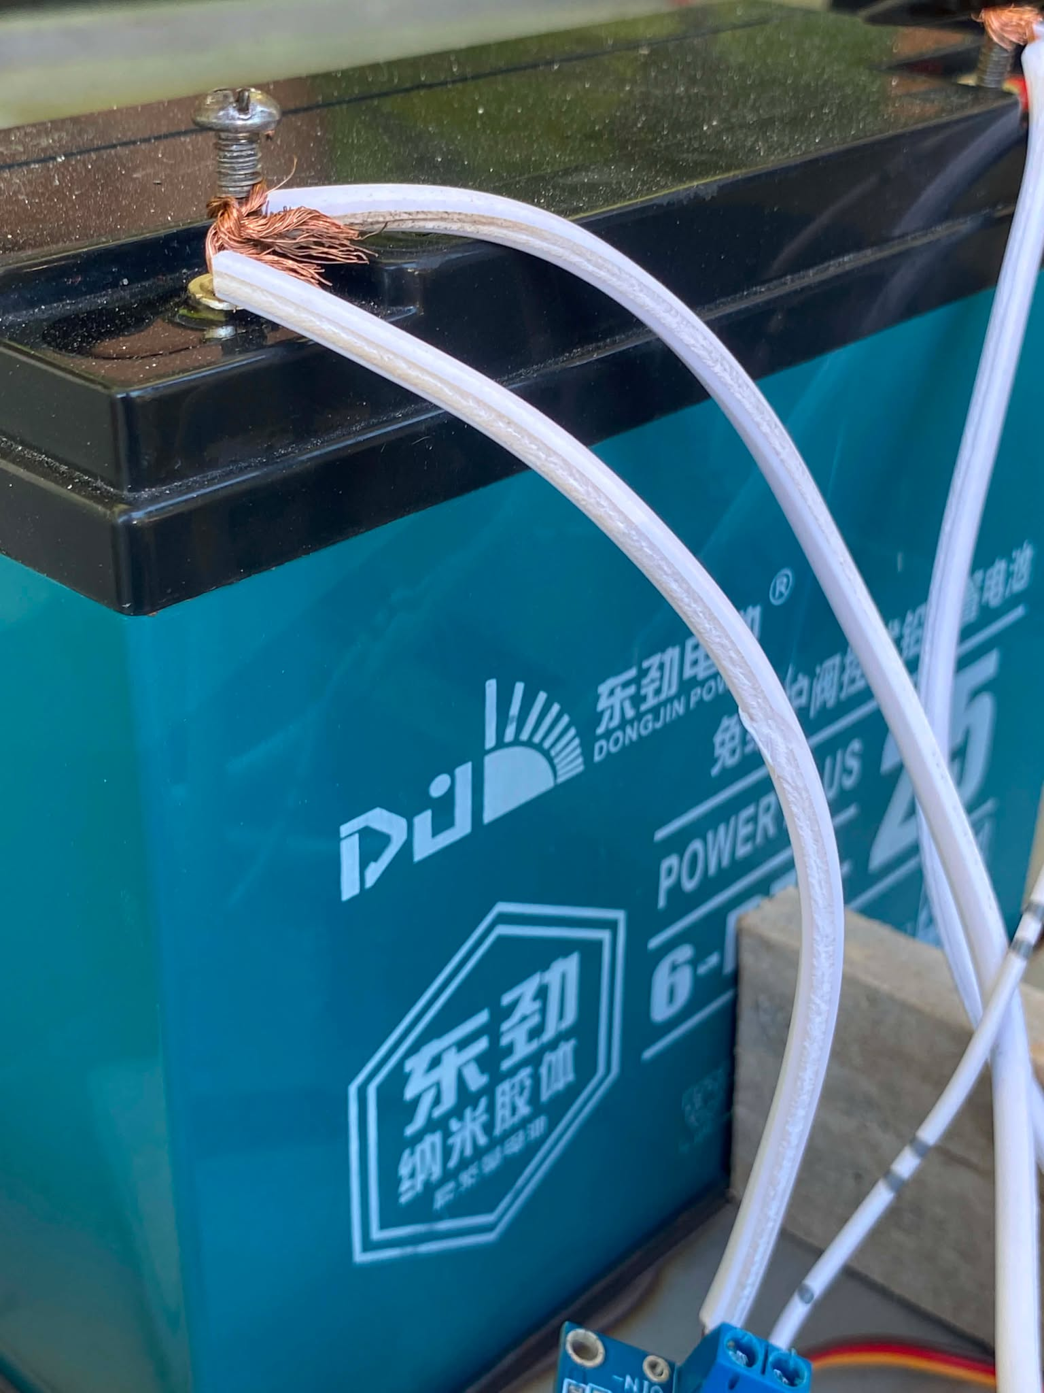
5 inch Universal Pneumatic Heavy Duty Roller 2x |  |  | 